Mohammed Al-Ojaimi Energy Services
Automation Department
Utility-Grade Automation for Mission-Critical Facilities
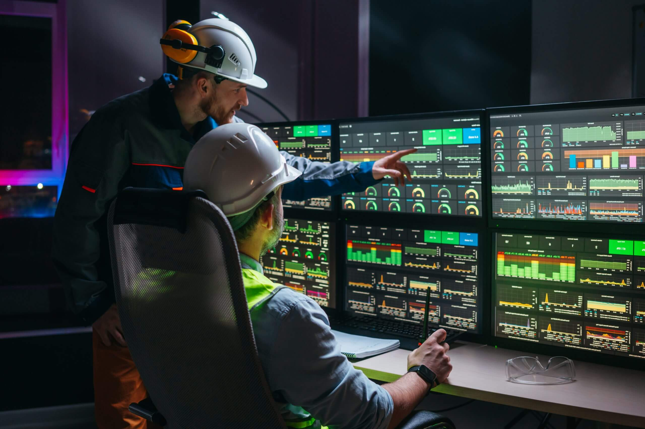
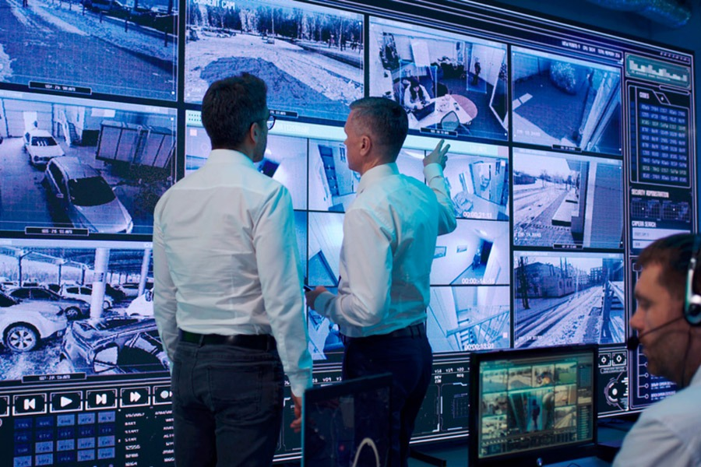

4

Who We Are
Mohammed Al-Ojaimi Energy Services – Automation Department delivers utility-grade automation and digital operations platforms for mission-critical facilities where downtime, data loss, or system failure is unacceptable.
Our engineering heritage comes from large-scale power utility and grid automation projects, where systems must operate 24/7, under strict regulatory, cybersecurity, and redundancy requirements.
We apply this same discipline to industrial factories, medical campuses, mega buildings, and large infrastructure projects.

What Makes Us Different
We are not a typical BMS or low-cost system integrator.
We design and deliver operations-critical automation architectures, focusing on:
- Reliability
- Scalability
- Cyber-secure design
- Long-term lifecycle value
“If it can operate a power grid, it can safely operate your factory, hospital, or data center.”

Core Capabilities
- Enterprise SCADA & Operations Platforms
Plant-wide and multi-site monitoring, control, and analytics
- Industrial & Process Automation Integration
PLC / DCS / OEM system integration under a unified architecture
- Operational Intelligence & Analytics
OEE, energy optimization, downtime analysis, KPI dashboards
- Mission-Critical Network Architecture
Segmented OT networks, redundancy, virtualization, disaster recovery
- Alarm Management & Event Rationalization
IEC-grade alarm philosophy for fast and safe decision-making
- Lifecycle Engineering & Support
Engineering, commissioning, FAT/SAT, as-built documentation, long-term support

Technology Philosophy
We implement open, vendor-agnostic architectures built on proven industrial platforms such as COPA-DATA zenon, integrated with best-in-class PLCs, sensors, historians, and OT infrastructure.
This approach ensures:
- No vendor lock-in
- Future scalability
- Smooth integration of existing and future systems

Target Applications
- Large Industrial & Process Plants
(Manufacturing, FMCG, food & beverage, cement, steel, chemicals)
- Medical Cities & Mega Hospitals
(Power, HVAC, medical gases, UPS, generators, centralized command centers)
- Mega Buildings & Data Centers
(Enterprise facilities, mixed-use developments, mission-critical infrastructure)

Project Profile
- Typical Project Size: 7 – 10+ Million SAR
- Delivery Model: EPC / PMC-aligned execution
- Engagement Type: Design-build, modernization, expansion, digital transformation
We selectively engage in high-impact, high-responsibility projects where engineering quality, operational continuity, and long-term value matter more than lowest initial cost.

Our Value to Clients
- Reduced unplanned downtime
- Improved operational visibility and control
- Lower lifecycle cost of ownership
- Future-ready automation architecture
- Single accountable automation partner

Our Promise
We don’t just deliver automation systems.
We deliver operational confidence.

